BLOOD BANK MANAGEMENT SYSTEM

**18CSC209J - Database Management System and Cloud Integration Services**

## Mini Project Report

*Submitted by*

## RUPESH ROSHAN SAHOO[RA2111028010194] B.Tech. CSE - CLOUD COMPUTING

**ADITYA KUMAR[RA2111028010175] B.Tech. CSE - CLOUD COMPUTING**



**DEPARTMENT OF NETWORKING AND COMMUNICATION SCHOOL OF COMPUTING**

**COLLEGE OF ENGINEERING AND TECHNOLOGY SRM INSTITUTE OF SCIENCE AND TECHNOLOGY**

**(Under Section 3 of UGC Act, 1956)**

S.R.M. NAGAR, KATTANKULATHUR – 603 203 KANCHEEPURAM DISTRICT

**MAY 2023**

**TABLE OF CONTENTS**

|  |  |  |
| --- | --- | --- |
| **Chapter No.** | **Title** | **Page No.** |
| 1. | Abstract |  |
| 2. | Introduction |  |
| 3. | Problem Statement |  |
| 4. | Module Description |  |
| 5. | Use case diagram |  |
| 6. | ER diagram |  |
| 7. | Database Creation using DDL and DML |  |
| 8. | Normalization of Database |  |
| 9. | Implementation using Dynamo DB |  |
| 10. | Conclusion |  |
| 11 | Appendix I - Screenshot |  |
| 12 | Appemdix II - Github Profile |  |
| 13 | Appendix III - AWS Course Completion certificate |  |

# Abstract

Blood Bank Management System is a software application that helps manage and automate the operations of a blood bank. The system allows for the effective management of donor information, blood inventory, and blood requests. The abstract for the Blood Bank Management System describes the system's purpose, key features, and benefits. The system helps to streamline the blood bank's processes, reduce errors, and improve the efficiency of blood donation and distribution. The abstract also highlights the importance of the Blood Bank Management System in ensuring a safe and adequate blood supply for patients in need.

# INTRODUCTION

Blood Bank Management System is a software application designed to automate and streamline the processes involved in managing a blood bank. The system helps manage donor information, blood inventory, and blood requests, among other things. The Blood Bank Management System plays a critical role in ensuring the availability of safe and adequate blood supply for patients in need. The system allows for the effective management of the blood bank's operations, including the collection, testing, storage, and distribution of blood and blood products. With the help of the Blood Bank Management System, the process of blood donation becomes more organized, and it becomes easier to track and monitor blood inventory levels, ensuring that there is always enough blood available for patients who need it. The Blood Bank Management System also helps in maintaining accurate records of donor information, including their medical history and blood type. This information is essential in ensuring the safety of blood products and preventing the transmission of diseases through blood transfusion. In summary, the Blood Bank Management System is a critical tool for managing the operations of a blood bank, ensuring that there is an adequate supply of safe blood available for patients in need. It improves the efficiency of the blood bank's processes, reduces errors, and ultimately saves lives.

# Problem Statement

The management of a blood bank involves various challenges that can lead to inefficiencies and errors. Some of the problems that the Blood Bank Management System aims to address are:

1. Inefficient inventory management: Blood banks may struggle to maintain an adequate supply of blood due to a lack of real-time information on blood inventory levels. This can result in delays in providing blood to patients who need it urgently.
2. Manual record-keeping: Blood banks may rely on paper-based systems to manage donor information, blood inventory, and blood requests. This can be time-consuming, prone to errors, and difficult to maintain.
3. Inaccurate donor information: Blood banks may not have up-to-date information on donor medical history, blood type, and eligibility to donate blood. This can lead to the transmission of diseases through blood transfusion and compromise patient safety.
4. Inefficient blood distribution: Blood banks may struggle to distribute blood to hospitals and clinics in a timely and efficient manner, leading to delays in patient care.

The Blood Bank Management System aims to address these problems by automating and streamlining the blood bank's processes, improving inventory management, providing real-time information on blood inventory and availability, and maintaining accurate records of donor information.

**Module Description**

The Blood Bank Management System comprises several modules that work together to manage the operations of a blood bank efficiently. Below is a brief description of each module:

1. **Donor Module:** This module is responsible for managing donor information, including their personal details, medical history, and eligibility to donate blood. It helps the blood bank maintain accurate records of donors and ensure the safety of blood products.
2. **Blood Inventory Module:** This module is responsible for managing the blood bank's inventory, including blood type, quantity, and expiration dates. It provides real-time information on blood inventory levels, making it easier to manage the supply of blood and avoid shortages.
3. **Blood Donation Module:** This module manages the process of blood donation, from scheduling appointments to collecting blood samples and testing them for diseases. It helps streamline the donation process and ensure that donors meet the eligibility criteria for donating blood.
4. **Blood Request Module:** This module manages the process of blood requests from hospitals and clinics. It helps the blood bank prioritize blood requests based on urgency and availability and ensures timely delivery of blood products.
5. **Reporting Module:** This module generates reports on blood inventory, donor information, and blood requests. It provides insights into the blood bank's performance and helps identify areas for improvement.
6. **Administration Module:** This module manages the system's administrative tasks, including user management, system configuration, and data backup. It ensures the system's smooth operation and security.

**DDL and DML comand**

**Donor module:**

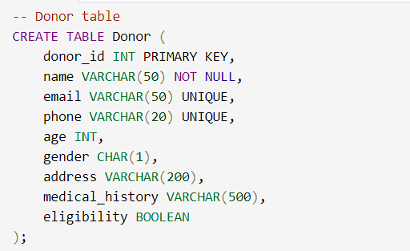

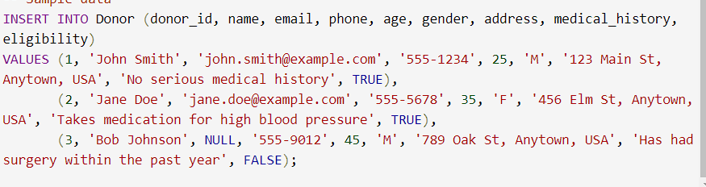

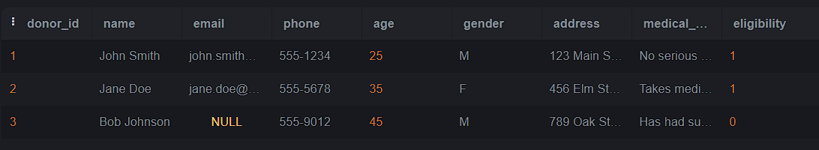

**Blood Inventory Module:**

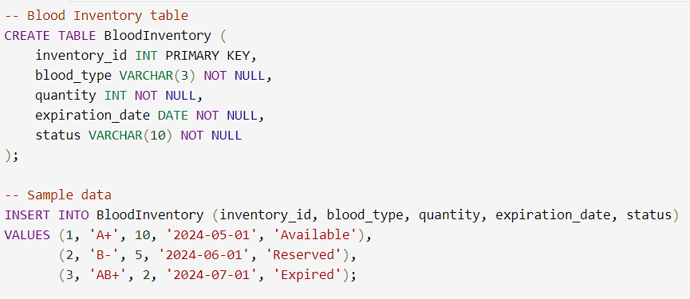

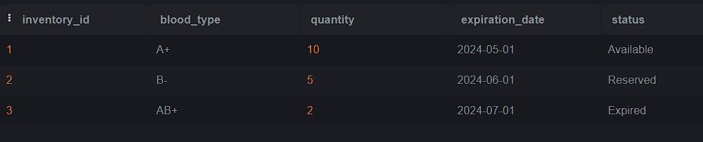

**Blood Donation Module: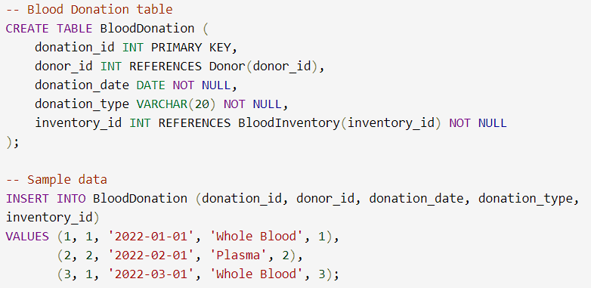e:** 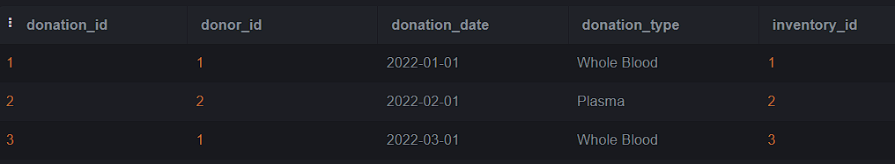

**Blood Request Module:**

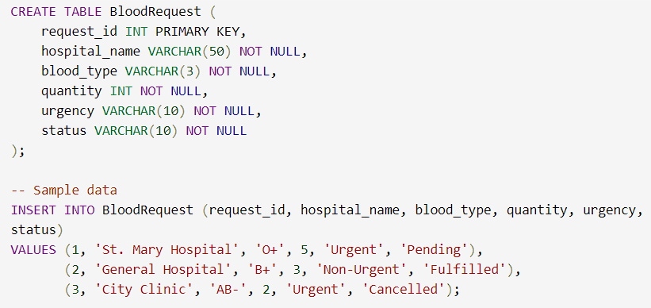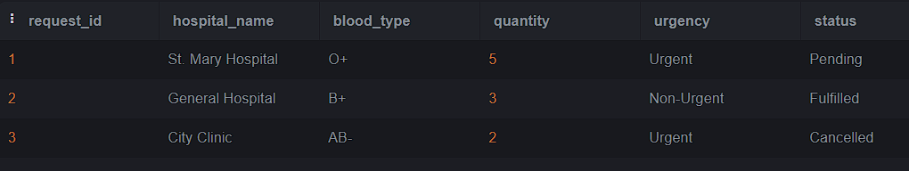

**Reporting Module:**

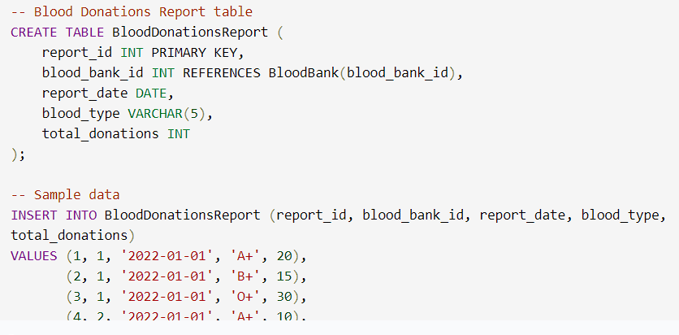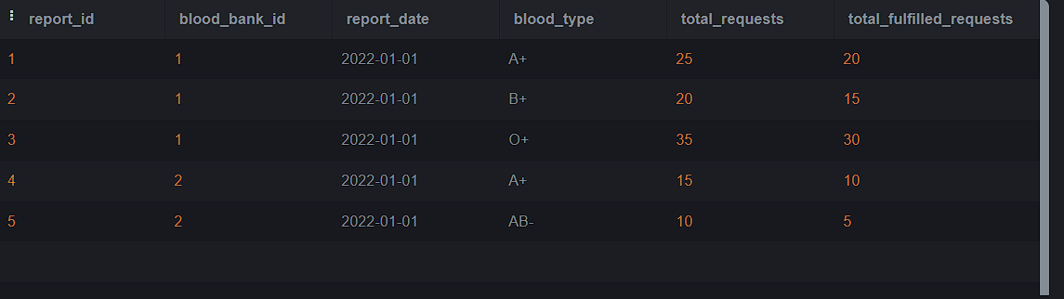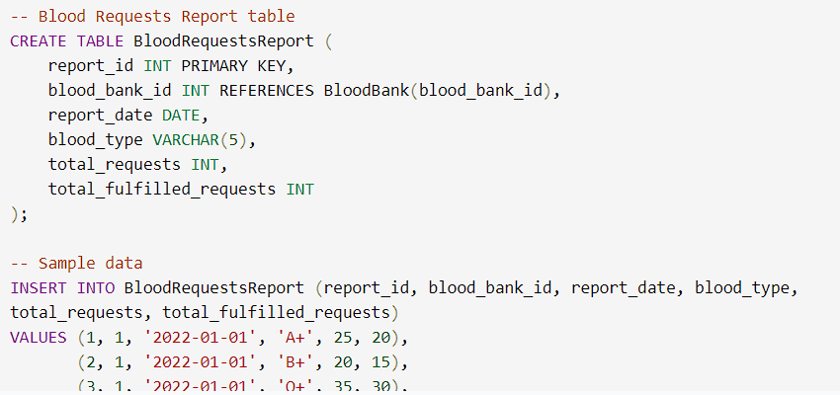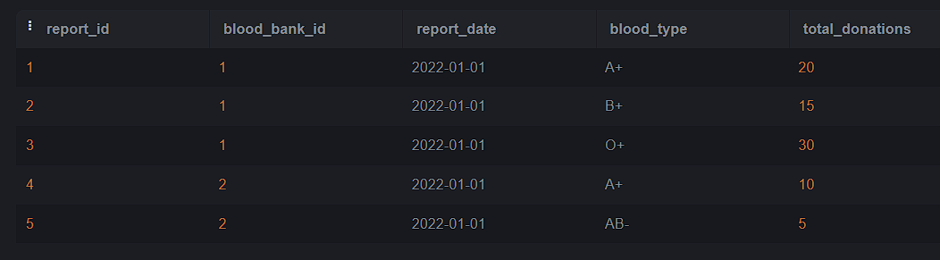

**Administration Module:**

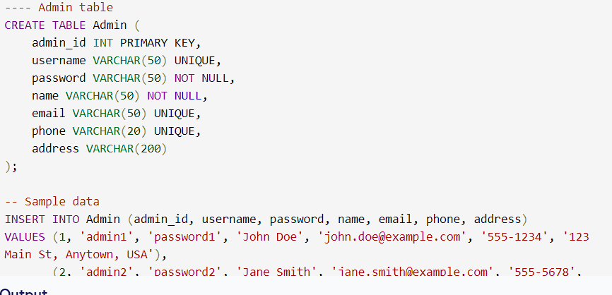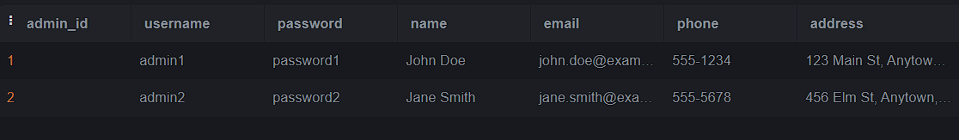

Use case diagram

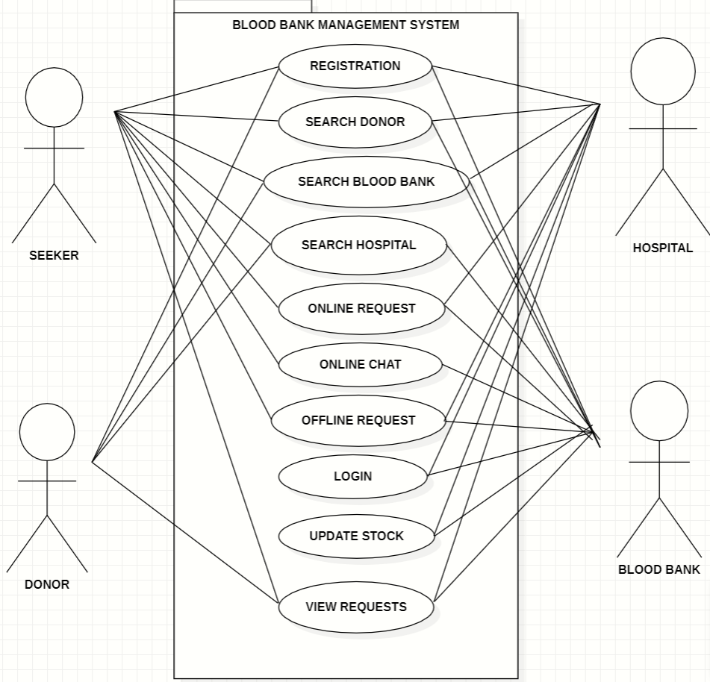

ER diagram

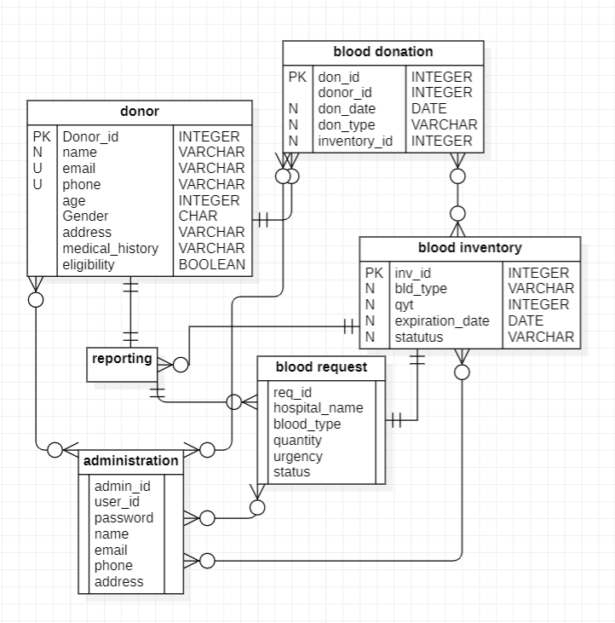

**NORMALIZATION**

Normalization is an essential part of database design to ensure that

data is stored efficiently and accurately in a relational database. A

Blood Bank Management system typically involves multiple tables that capture

data related to employee, taxes, deductions, bonuses and benefits.

Here are some general guidelines for normalizing a database for a

Blood Bank Management system:

1. Identify the entities and their attributes: Start by identifying the

main entities involved in the POS system, such as donor,

donor_id, request, and blood_inventory etc. For each entity, list the

relevant attributes (fields) that need to be stored.

2. Apply the first normal form (1NF): Ensure that each table has a

primary key that uniquely identifies each row, and that all columns

in the table are atomic (i.e., indivisible).

3. Apply the second normal form (2NF): Ensure that each non-key

column in the table is fully dependent on the primary key. If there

are any partial dependencies, split the table into separate tables.

4. Apply the third normal form (3NF): Ensure that there are no

transitive dependencies between non-key columns. If there are any,

split the table into separate tables.

5. Normalize related tables: If there are related tables, ensure that

they are properly normalized and linked with appropriate foreign

keys.

6. Consider performance and scalability: As you design and

normalize the database, consider how it will perform and scale as

the data grows. This may involve demoralizing certain tables or

using indexing and other performance optimization techniques.

#### **IMPLEMENTATION OF DYNAMODB**

Amazon DynamoDB is a fully managed NoSQL database service that provides fast and predictable performance with seamless scalability. It can be a good fit for a Payroll system that requires high availability, low latency, and flexible scalability.

Here are some steps to consider for implementing DynamoDB in a Payroll system:

1. Identify the data model: Determine how the data in the POS system will be modelled in DynamoDB. This involves identifying the entities, attributes, and relationships involved in the system. For example, you might have tables for customers, products, transactions, and inventory.
2. Design the table schema: Design the schema for each table, including the primary key(s) and any secondary indexes. DynamoDB uses a partition key to partition data across multiple servers, so choosing a good partition key is critical for performance and scalability.
3. Choose the right access patterns: Consider the different ways that the data will be accessed and query the table accordingly. DynamoDB provides flexible querying options, including key-value lookups, range queries, and filtering.
4. Consider capacity planning: Estimate the read and write capacity required for each table based on the expected workload. DynamoDB uses a pay-per-request pricing model, so you can adjust the capacity up or down as needed to meet changing demand.
5. Implement error handling and retry logic: DynamoDB is designed for high availability and durability, but errors can still occur. Implement error handling and retry logic in your application to handle any errors that may arise.
6. Monitor performance and adjust as needed: Use the DynamoDB console or APIs to monitor the performance of your tables and adjust capacity as needed to maintain the desired level of performance.
7. Use best practices for security and compliance: Follow best practices for securing your DynamoDB tables, including using IAM roles and policies to control access, encrypting data at rest and in transit, and complying with any applicable regulations or standards.

When implementing DynamoDB in a Payroll system, it's important to carefully consider the data model, table schema, access patterns, capacity planning, error handling, performance monitoring, and security and compliance. By following best practices and leveraging the scalability and performance of DynamoDB, you can build a highly available and responsive POS system that meets the needs of your business and customers.

# Conclusion

the Blood Bank Management System is an essential software application for managing the operations of a blood bank. It provides a solution to the challenges involved in managing blood inventory, donor information, blood donation, blood requests, and reporting. By automating and streamlining these processes, the Blood Bank Management System helps the blood bank maintain an adequate supply of safe blood products and ensure patient safety.

The various modules in the Blood Bank Management System work together to provide real-time information, improve inventory management, streamline blood donation and distribution, and maintain accurate records. By doing so, the system helps reduce errors, save time, and increase efficiency.

The Blood Bank Management System plays a crucial role in ensuring the availability of safe and adequate blood supply for patients in need. It improves the blood bank's performance and provides insights into areas for improvement, thereby helping to save lives. Therefore, the Blood Bank Management System is an indispensable tool for any blood bank seeking to manage its operations effectively.

Appendix I – DYNAMO DB

